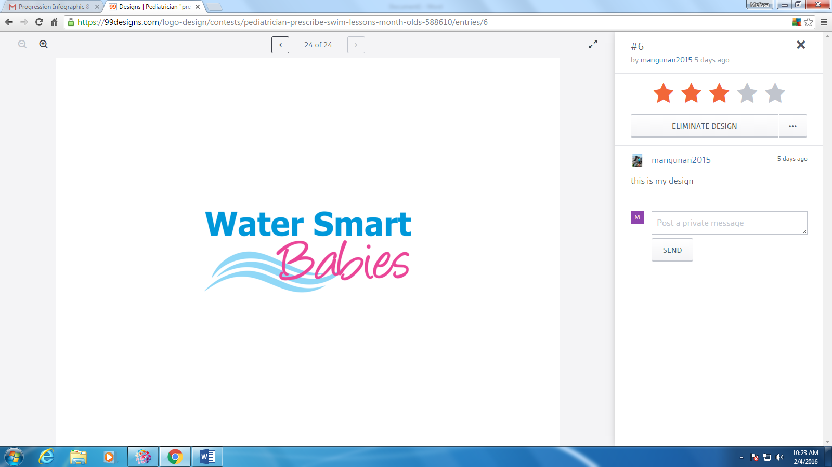

2019 Certification Opportunity

Water Smart Babies *Instructor & Trainer* Workshop **April 2019**9:00a – 12:00p Classroom (Dry)  
1:00p – 5:00p In Pool (Wet)  
 **LOCATION**  
NDPA Educational Conference  
Astor Crown Plaza – French Quarter  
[739](https://maps.google.com/?q=700+South+Florida+Ave+Tampa,+FL+33602+US&entry=gmail&source=g) Canal Street  
[New Orleans, LA 70130 US](https://maps.google.com/?q=700+South+Florida+Ave+Tampa,+FL+33602+US&entry=gmail&source=g)A **COST  
$100.00**

**PRE-REQUISITES:**

* Water Smart Babies on-line course (can be taken on-site)
* National Certification for teaching swim lessonsSAI, Red Cross, Ellis, USSSA, USA Swimming, FL state instructor  
  certification etc.(others may be accepted upon request)
* CPR Certification
* Become a Make a Splash local partner

**COURSE OBJECTIVES:**

* Learn the history of the program and its impact; it's partners and how they are involved
* How to start the program in your area (or ensure it is still up and running properly or grow it)
* Learn the role of reflexes in learning
* Work in the water with Lana Whitehead

**PRESENTERS:**

* Lana Whitehead, SWIMkids USA
* Melissa Sutton, NDPA & DPCA

**To register, please contact Melissa Sutton at** [**melissa.sutton@activekidsglobal**](mailto:melissa.sutton@activekidsglobal) **or at (480) 570-9830**

Water Smart Babies is a collaborative effort between:

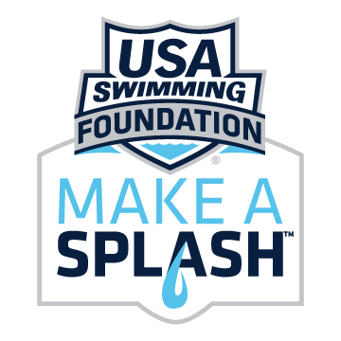  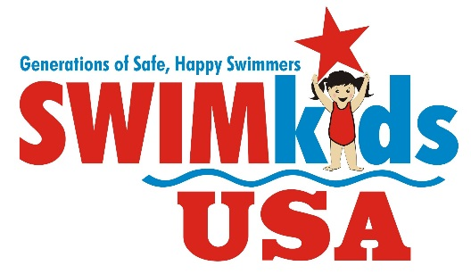   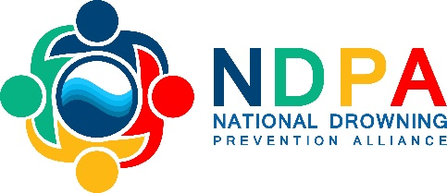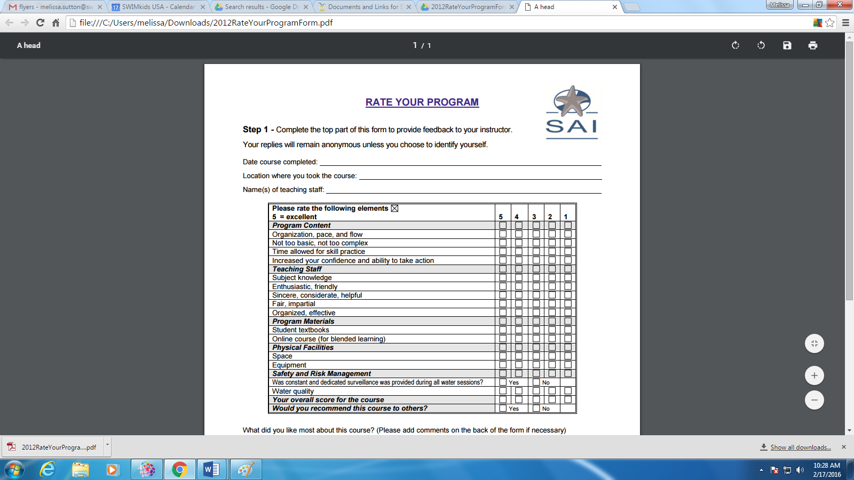

For more information on Water Smart Babies, please visit [www.watersmartbabies.com](http://www.watersmartbabies.com)