2016 Certification Opportunities
Water Smart Babies
Instructor Courses
DATE
May 13th & 14th
8:00a – 2:00p (Dry)
9:00a – 12:00p (Wet)
LOCATION
SWIMkids USA
2725 W. Guadalupe Road
Mesa, AZ 85202
COST
$100.00
^{Pre-requisite:}
- Water Smart Babies on-line course
- National Swimming Certification
- CPR & First Aid for the professional rescuer Certification

Water Smart Babies
Trainer Workshop
DATE
August 26th & 27th
8:00a – 7:00p (Wet & Dry)
9:00a – 4:00p (Wet)
LOCATION
SWIMkids USA
2725 W. Guadalupe Road
Mesa, AZ 85202
COST
$350.00
^{Pre-requisites:}
- Water Smart Babies on-line course
- National Swimming Certification
- CPR & First Aid for the professional rescuer Certification
- Have an existing learn-to-swim program

To register, please contact Melissa Sutton at melissa.sutton@swimkidsusa.us or at (480) 820-9109
Water Smart Babies is a collaboration effort between:
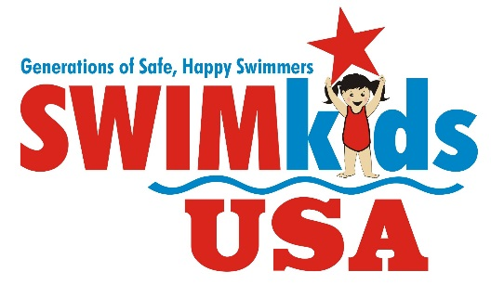
For more information on Water Smart Babies, please visit www.watersmartbabies.com

